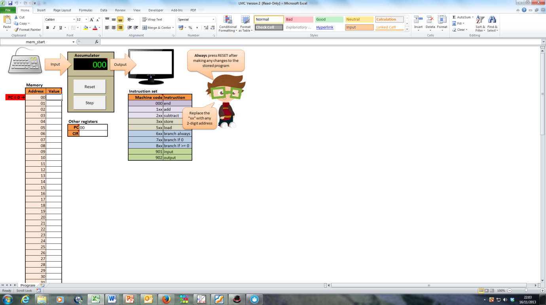**Little Man Computer**

*New Curriculum statement*

“explain how instructions are stored and executed within  
a computer system “

Using the LMC (Little Man Computer) spreadsheet you can   
understand how Von Neumann computer architecture works.

**Example**

In memory address 20 enter the number 14.

In memory address 21 enter the number 26

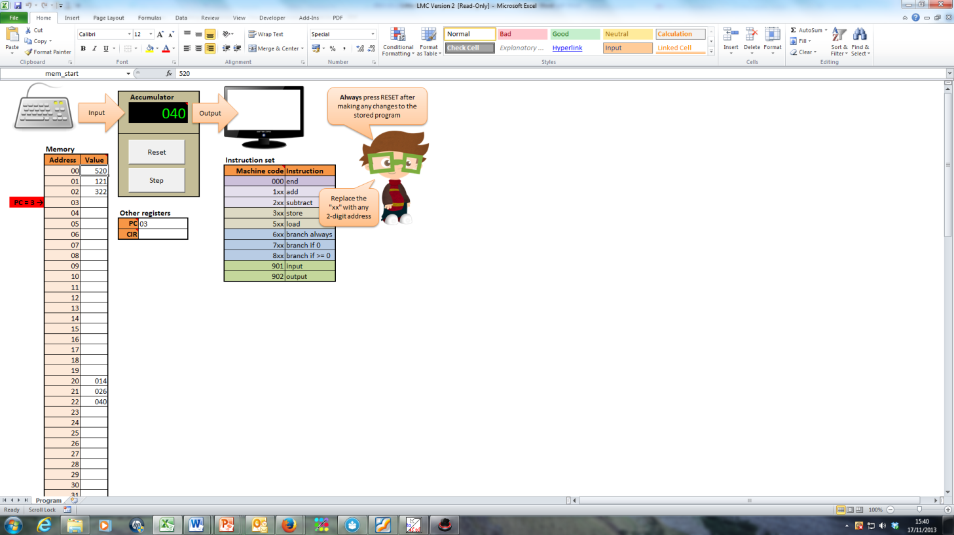Now, starting at address zero enter the following program.

520 – Load Accumulator with the value at memory address 20 (i.e. the value 14)

121 – Add to the accumulator the value at memory address 21 (i.e. the value 26)

322 – Store the value of the accumulator at memory address 23.

**Tasks (for each program draw a flowchart or use pseudo code to describe the program)**

1. Write a program that will subtract two numbers and store the result in memory location 30.

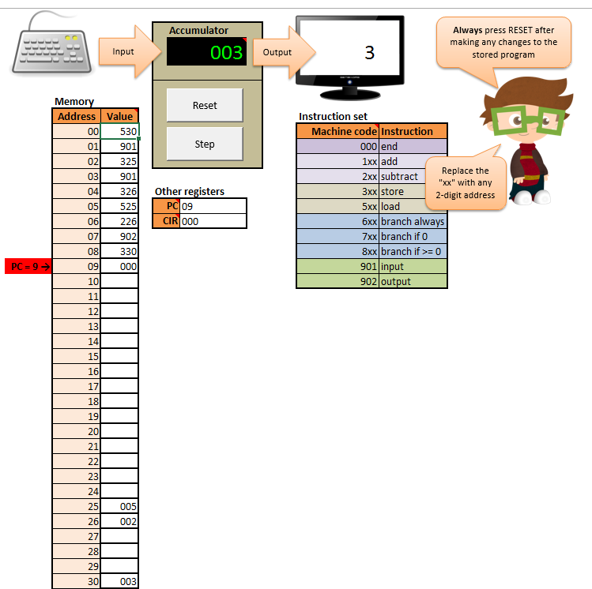

1. Write a program that will add two numbers and store the result in memory location 25.

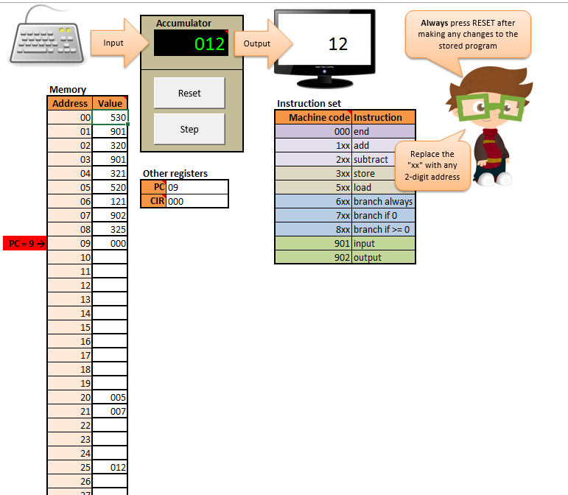

1. Write a program that will count up to 10 and then stop.

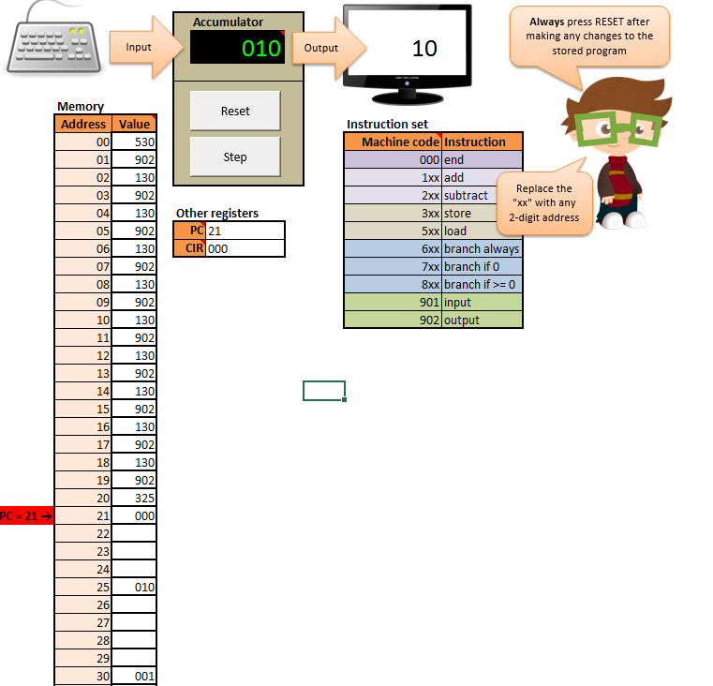

1. Write a program that will allow the user to enter a number to count down to zero from and then stop.

